Suggested Mark Scheme

1 | Fig. 1 shows part of an animal cell as seen through an electron microscope.

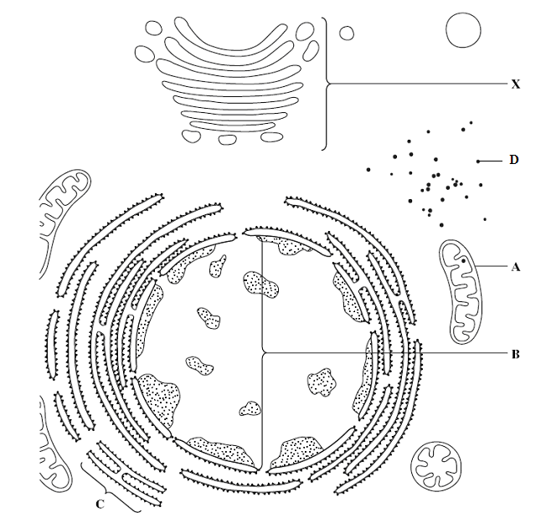

Fig. 1

 | (a) | Identify structures A – D.
 |  | A | mitochondria | C | rough endoplasmic reticulum
 |  | B | nucleus / nucleoplasm / chromatin | D | ribosome | [2]
 | (b)(i) | Identify and describe the function of structure X.
 |  | - Golgi apparatus;
 |  | - unfinished prot in trspt vesicle fr rER fuse with cis face where prot is sorted, packaged & modified;
 |  | - sugar units are adde,/ deleted or sub in oligosacc chain of glycoprot to form molecular ID tag;
 |  | - finished prto pinch off in secretory vesicle / as lysosome; |  |  |  |  | [3]
 | (ii) | Explain how X is adapted to perform its function.
 |  | - with polarity, with cis & trans face to receive & trspt unfinished & finished prot to diff locations;
 |  | - cisternal space with enz to modify oligosacc chain;
 |  | - discrete cisternae to compartmentalise diff processing stages; |  |  |  |  | [2]
 | (c) | Membranes of A, C and X all share the same basic structure.
 | (i) | Describe the basic structure of these membranes.
 |  | - all with fluid mosaic model consisting of phospholipids bilayer;
 |  | - with integral & peripheral prot scattered among lipid layers; |  |  |  |  | [2]
 | (ii) | Explain how the membranes differ in structure for A, C and X to perform different functions.
 |  | - presence of diff mem prot e.g. e- carriers embedded in inner mem of A / presence of receptor on C to bind signal peptide;
 |  | - diff types of phospholipids with oligosacc to interxt with other molecules; |  |  |  |  | [2]
 |  | [Total: 11]

2 | Fig. 2 shows the stages of a eukaryotic cell cycle.  M phase  spindle checkpoint  G2 checkpoint  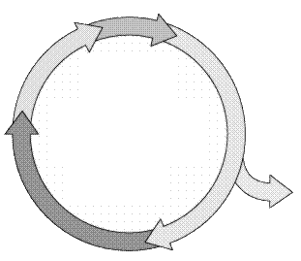  S phase  G₁ phase  Cell cease to divide  G₂ phase  G1 checkpoint  Fig. 2
 | (a) | Briefly describe the events during the M phase.
 |  | - prophase where chromosome condense, spiralise / centrioles migrate / aster forms / nuclear mem disintegrate / nucleolus disorganise;
 |  | - metaphase, chromosome line up at metaphase plate;
 |  | - anaphase, sis chromatids separate to oppo poles of cell;
 |  | - telophase, chromosome decondense / nuclear mem reform, cytokinesis occurs; | [3]
 | (b) | Cell division is a highly regulated process. The cell passes a series of checkpoints before proceeding and completing mitosis.
 | (i) | On Fig. 2, label the cell cycle checkpoints. [1]
 | (ii) | Describe how the cell cycle is regulated at the checkpoints illustrated in (b)(i).
 |  | - G1 chkpt, chk for correct cell size, presence of GF, DNA damage;
 |  | - G2 chkpt, chk for proper DNA replication, DNA damage, proper organelle replication;
 |  | - spindle chkpt, chk for proper spindle attachment to centromere; | [3]
 | (c) | Explain why cancer is a multi-step process.
 |  | - proto-oncogene undergo gain-in-fn mutation to oncogene;
 |  | - tumour suppressor gene undergo loss-in-fn mutation;
 |  | - telomerase activated / angiogenesis / loss of contact inhibition / loss of anchorage dependence; | [3]
 |  | [Total: 10]

3 | (a) | Explain what is meant by a gene.
 |  | seq. of DNA nucleotides coding for a fnal prot or RNA molecule; | [1]
 | (b) | Red-green colour blindness is a sex-linked recessive trait. A woman with blood group A whose father is colour blind married a colour blind man with blood group O. The couple's first child is a normal vision boy with blood group O.
 | (i) | Illustrate the above results in a genetic cross.
parental genotype X^{B}X^{b}I^{A}I^{O} x X^{b}YI^{O}I^{O} (1m)

gametes X^{B}I^{A} X^{b}I^{A} X^{b}I^{O} YI^{O} (1m)
X^{B}I^{O} X^{b}I^{O}

Punnett sq (1m)

[3]

 | (ii) | Calculate the probability of the couple having a colour blind daughter with blood group A. Show your working.  prob child with blood grp A = 0.5  prob of colour blind daughter = 0.25  total = 0.5 x 0.25 = 0.125;  [1]
 | (iii) | Explain why it is more common for males to be colour blind.
 |  | males with only 1 X chromosome / are heterogametic, thus cannot be heterozygous / carriers, only req. 1 recessive allele to be colour blind; | [1]
 |  | [Total: 6]

4 | Fig. 4 shows the three stages involved in the polymerase chain reaction (PCR).  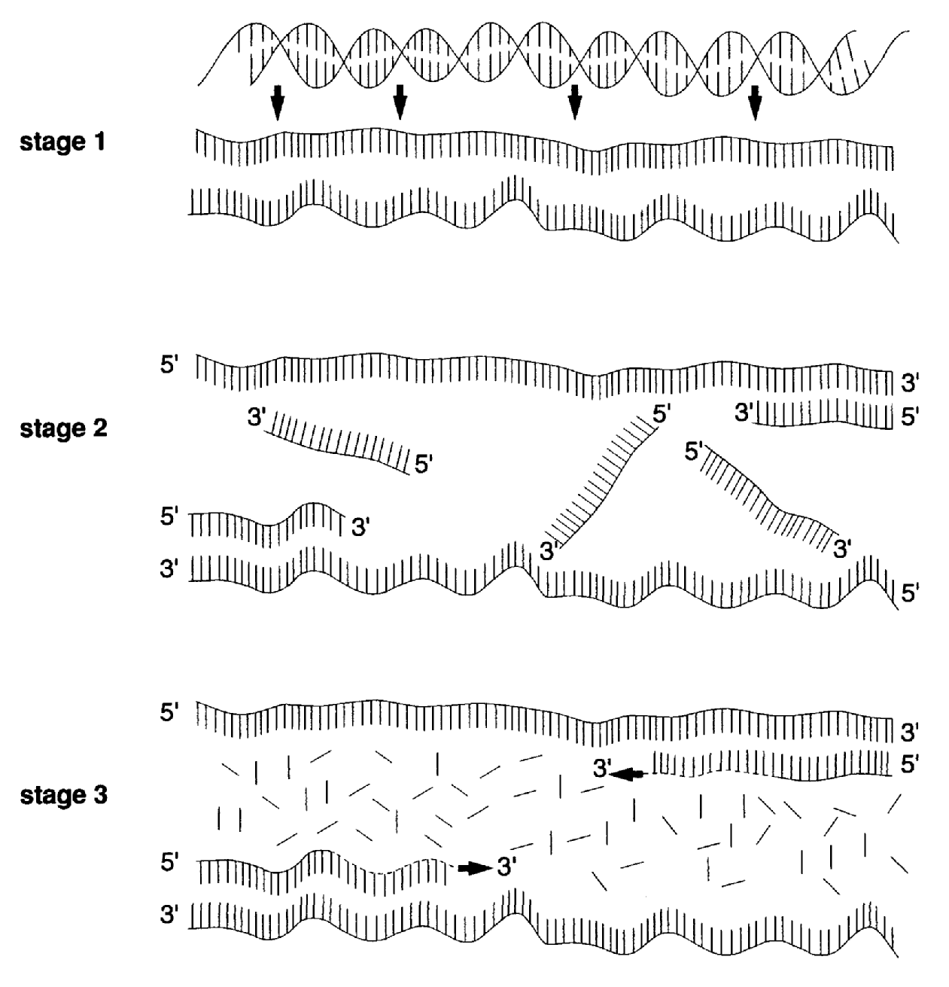  Fig. 4
 | (a) | With reference to Fig. 4, describe the events in stage 1 to 3.
 |  | Stage 1:
 |  | - Denaturation at 90 – 99ºC, break H-bonds btw complementary bases;;
 |  | Stage 2:
 |  | - Annealing/hybridization at 50 – 55 ºC, H-bonds formed between primers and ssDNA flanking target regions;;
 |  | Stage 3:
 |  | - Elongation of primers at 70 – 75ºC, Taq DNA pol brings in complementary deoxyribonucleotides to template strand;;
 |  | - Catalyse formation of phosphodiester bonds between adj incoming nucleotides;; | [4]
 | (b) | Calculate the number of copies of the target sequence after 25 cycles of PCR. Show your working.  2²⁵ = 33554432 DNA copies;; (note: not counting originals)
 | (c) | DNA polymerase, Taq polymerase, from thermophilic bacteria Thermophilus aquaticus is used in PCR. Explain why Taq polymerase is chosen rather than human DNA polymerase.
 |  | - higher optimum temp @ 70ºC, able to withstand denaturation temperature;;
 |  | - allows for repeated heating cycles in an automated thermal cycler w/o need for repeat additions of enzymes;; | [2]
 | (d) | PCR is frequently used in genetic engineering. Describe how PCR can be used in the process of genetic engineering.
 |  | - required minute amounts of DNA as starting material;;
 |  | - increases the number of target DNA for analysis;; | [2]
 | (e) | The PCR process sometimes results in the generation of both target and non-target sequences.
 | (i) | Explain why non-target sequences are sometimes produced in PCR.
 |  | - primers used were not specific, bound to seq flankin non-target sequence;; | [1]
 | (ii) | Describe how the products of PCR can be checked to ensure that the target sequence is synthesized.
 |  | - uses agarose gel as molecular sieve;;
 |  | - distance moved inversely proportional to molecular size;;
 |  | - application of direct current, results in negative charged DNA traveling to positive electrode;; | [3]
 |  | [Total: 13]

Section B
Answer any one question.

Write your answers on the separate answer paper provided.
Your answers should be illustrated by large, clearly labelled diagrams, where appropriate.
Your answers must be in continuous prose, where appropriate.
Your answers must be set out in section (a), (b) etc., as indicated in the question.

5 | (a) | Describe the structure of DNA and its organisation in a eukaryotic chromosome. [6]
- 2 polymers of deoxyribonucleotides chains twisted into a double helix;;
- held by H- bonds between complementary bases, A=T, C≡G;;
- 2 nm diameter, 0.34nm/10 bp per complete turn;;
- distinct polarity 3’ end with free hydroxyl group at 3C and 5’ end with phosphate group at 5C;;
- DNA molecule associated with 8 histone proteins/octomer, formed nucleosome core;;
- histones positively charged, formed ionic bonds with negatively charged DNA;;
- associate with H1 histone to form nucleosome, linked by spacer/linker DNA forming 10nm ‘beads-on-string’ structure;;
- further coiled into a solenoid forming a 30nm fibre;;
- futher looping in presence of scaffold proteins to form metaphase chromosomes;;

(MAX 3m for structure/organisation)

 | (b) | Describe how information on DNA is used to synthesise polypeptides in eukaryotes. [10]
Transcription
- RNA polymerase binds to the DNA sense strand/template, recruits ribonucleotides with complementary bases to template;;
- A=U, T=A, C≡G;;
- formed phosphodiester bonds btw incoming nucleotides;;
- formed ss pre-mRNA, with 5’ capping with modified guanine/methylated guanine;;
- 3’ polyadenylation for stability/ nuclear export of mature mRNA;;
- splicing of introns out and joining of exons forms mature mRNA;;
Translation
- assembly of translation initiation complex in cytoplasm, consisting of ribosomal subunits with petidyl site, aminoacyl site for tRNA, mRNA, tRNA in A site;;
- start codon AUG codes for met, tRNA^{met} moved to P;;
- tRNA with complementary anticodon brought into the A site;;
- peptidyl transferase catalyse the peptide bond btw aa;;
- tRNA with dipeptide moved to P site, free tRNA exits through E site;;
- reading of stop codon, release factor binds;;
- dissociation of translation cplx, release of polypetide;;

 | (c) | Outline the roles of restriction enzymes in genetic engineering. [4]
- RE recognises specific palindromic sequences on target DNA;;
- cleaves phosphodiester bonds in the sugar-phosphate backbone;;
- forming sticky ends in staggered cuts, blunt ends in straight cuts;;
- produced plasmids and target DNA with complementary ends for formation of recombinant plasmids in presence of ligase;;
 |  | [Total: 20]

6 | (a) | Describe how the Calvin cycle differs from the Krebs cycle. [7]

 | Descriptor | Calvin Cycle | Krebs Cycle
1 | location | Stroma in chloroplast | Matrix in mitochondrion;;
2 | ATP involvement | Uses 3 molecules of ATP per cycle in reducing GP to TP per cycle | Produces 1 molecule of ATP per cycle in oxidation of 4C compounds;;
3 | Coenzymes | Reduced NADPH | NADH and FADH;;
4 | Role of CO₂ | Used as a substrate in carbon fixation; | Product of oxidative decarboxylation;;
5 | Nature of reactions | Anabolic reaction | Catabolic reaction;;
6 | Metabolic process involved | Photosynthesis | Respiration;;
7 | Regeneration of compounds | 5C RUBP regenerated | 4C OAA regenerated;;

 | (b) | Explain the small yield of ATP under anaerobic conditions in both yeast and mammals. [8]
- absence of oxygen, lack of final electron acceptor;;
- ETC, Krebs cycle, link reaction stopped;;
- lack of regeneration of e- carrier, NAD+ and FAD+, only glycolysis in cytoplasm;;
- 2 molecules of ATP produced per molecule of oxidation of TP to pyruvate in substrate level phosphorylation;;
- 2 molecules ATP used in priming reactions in activation of glucose, net 2 molcules ATP produced;;
- anaerobic respiration regenerates NAD+ in anerobic respiration ;;
- pyruvate à ethanol + CO₂;;
- pyruvate à lactate;;

 | (c) | State the similarities between ATP production in mitochondria and chloroplasts and suggest why these similarities exist. [5]
- presence of ATP synthetase, catalyse production of ATP from ADP;;
- energy derived from proton gradient set up in across membranes;;
- intermembrane space in mitochondria, thylakoid space in chloroplasts;;
- proton gradient set up by e- movement down ETC;;
- similarities exist due to prokaryotic origins, entered endosymbiotic relationship with eukaryotic cells during evolution;;

 |  | [Total: 20]

